AWS Task-1

Task Description:

Create a windows Vm machine in AWS and connect with RDP open CMD in windows share the about system info.

- Created an instance with Windows AMI
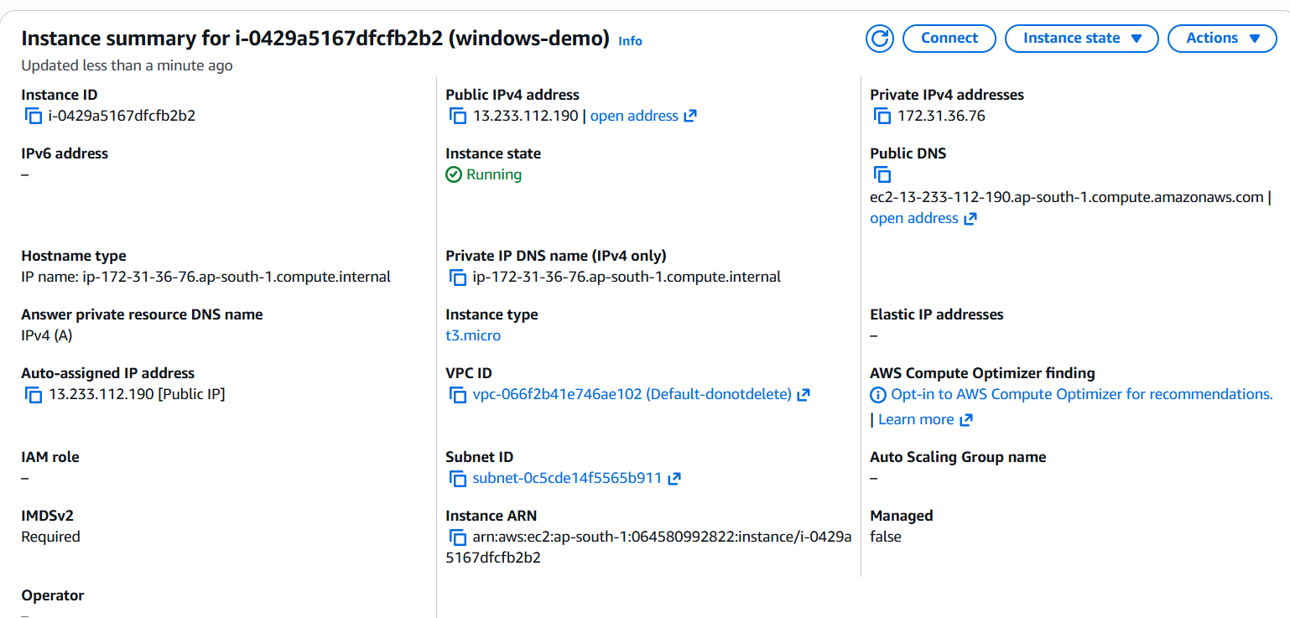

- Taking public IP and connecting via RDP
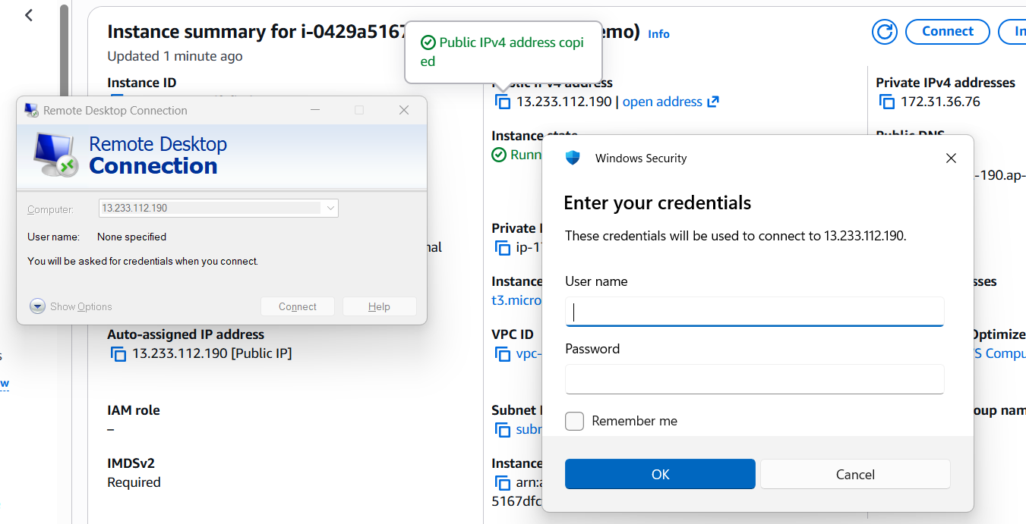

- Entering credentials taken from RDP client of windows instance created
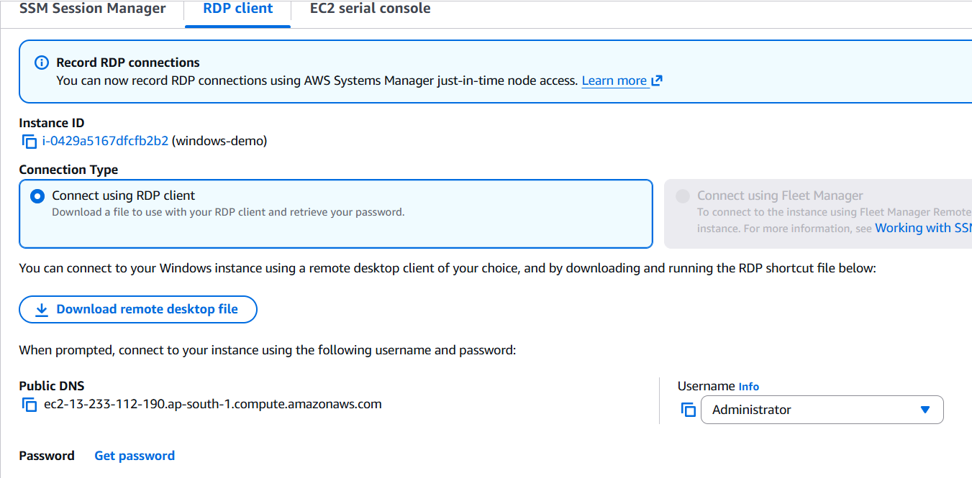
- Systeminfo of launched RDP in command prompt
